Research Design Results for Otis

Sage Babish

**Main Takeaways:**

* I wasn’t sure whether to use treatment as defined by life histories versus treatment defined by specific species combos versus just the focal species and some things were repeated several times because of this
* The flower and seed total data is not normally distributed enough to perform a (M)ANOVA because so many individuals produced 0; I was able to use a non-parametric alternative to establish when there were differences between groups but couldn’t estimate the magnitude of that difference

**1: Data Set-up**

No actual results from this section, but two notes:

* I ended up using both date 8 and date 9 for survival measurements because there was a single species alive at date 9 and I wasn’t sure if that was a product of the fast life-history species dying sooner and thus expected or a surprising outlier; when I ended up making models I made some with both survival measurements as a response
* I made my own csv for barrel keys to look at the treatments that’s adapted from the version Otis posted, it’s in the folder with the results (and this doc) and is necessary to run the code

**2: Data Exploration**

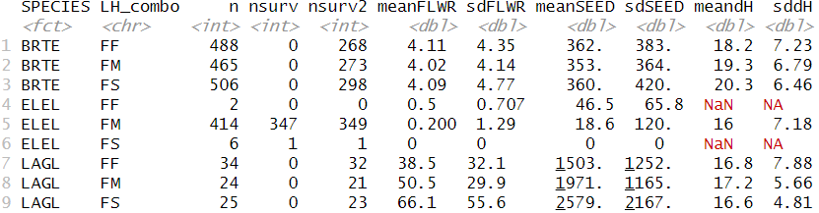

* ELEL was the only species to survive to date nine (nsurv); I’m not sure how any of it was recorded occurring in FF or FS treatments (could be on my end when adding LH_combo column or could have been a data entry issue)
* The mean FLWR and meanSEED results are interesting in how much they vary between species but are pretty constant across treatments
* Not summarized here, but in the boxplots below you can see some height variation btw species and treatments

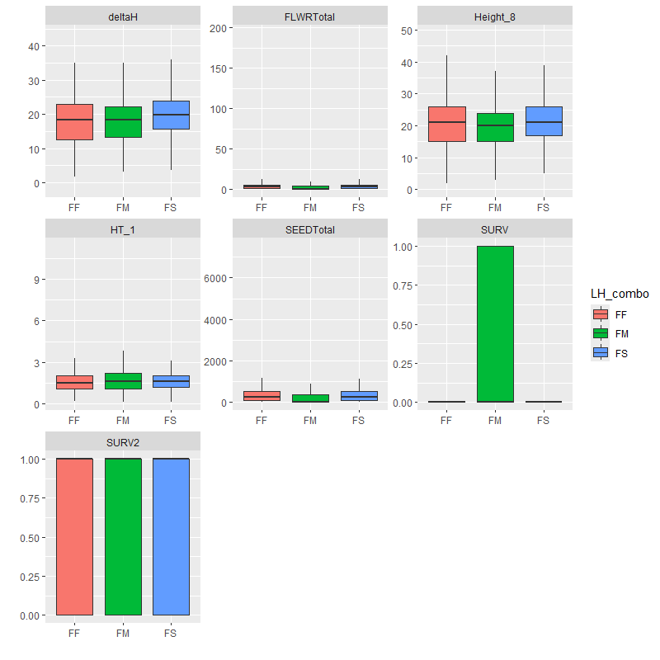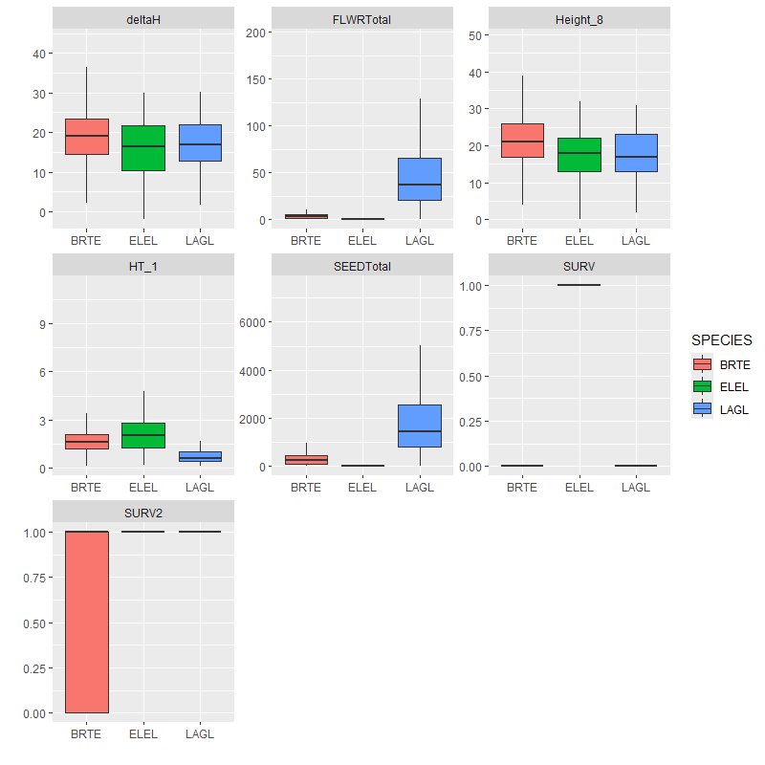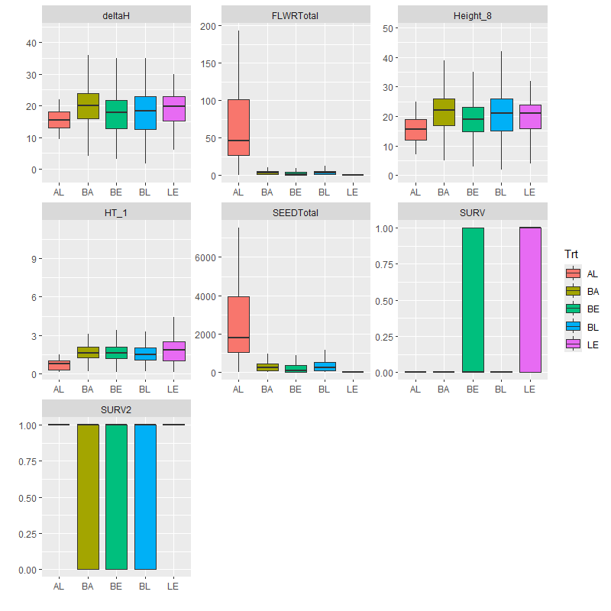

**3: ANOVA/MANOVA/non-parametric alternatives**

I initially planned to do a MANOVA, but quickly saw that the data weren’t normally distributed and opted for a perMANOVA instead, but it kept giving me errors with the distance metric I chose and I couldn’t find one I thought would also be appropriate. I ended up doing Kruskal-Wallis and pairwise Wilcox tests to see if the different groups differed and, if so, which groups differed. I could not figure out how to get these tests to actually estimate the differences between groups, which was annoying and I apologize that this result isn’t the most informative.

All species produced very different numbers of flowers and seeds. BRTE was taller than ELEL and LAGL (interesting because they do overlap a good bit on the box plots above). When comparing the FF, FM, and FS treatment groups, all three had different heights of plants at time 8. FM produced less flowers or seeds than the other two treatments, probably only because ELEL (the medium LH plant) produced so few.

**4: Survivorship Models**

I attempted to make GLMs and GLMMs for survival with a number of predictor variables, including species, treatment, LH combo, native versus invasive, and barrel (as a random effect). A lot of them returned errors, either about some probabilities being 0 or 1 (unsurprising when modeling SURV because only ELEL survived to date 9) or about coefficients not being defined because of singularities. The singularities thing is supposed to be a result of some variables being explained by others, which makes sense with the format of the data but even the minimal models had issues and I wasn’t sure how to best handle it. Hopefully this section is at least useful as an example of what doesn’t work (rip).

Models that worked (defined all coefficients):

* SURV ~ Trt + Native (Treatment as factor and NvI)
  + However the SE of each coefficient was way too big to be meaningful
* SURV2 ~ Trt + Native (Treatment as factor and NvI)
  + Being native increased odds of survival by 3.838
  + BA increased odds by 0.405, BE increased odds by 0.424, BL increased odds by 0.364, and LE increased odds by 0.382

Models that didn’t work (define all coefficients) but were educational:

* SURV2 ~ ELEL + BRTE + LAGL + FF + FM + FS + (1 | BARREL)
  + This actually did have lower AIC than the same model without the random effect (2401.6 vs 2430.8) so the random effect is probably worth including
* SURV2 ~ ELEL + BRTE + LAGL + FF + FM + FS + (ELEL | BARREL)
  + This one also had a slightly lower AIC, 2396.9, so random slope + intercept may be worth including
* SURV2 ~ LH_F + LH_M + LH_S + Native + (Native | BARREL)
  + Produced similar results to model above (AIC 2395.7 but rank deficient) which suggests either combination of these variables is useful

Models that didn’t work (couldn’t fully define coefficients):

* SURV ~ ELEL + BRTE + LAGL + FF + FM + FS (species and LH combo)
* SURV2 ~ ELEL + BRTE + LAGL + FF + FM + FS (species and LH combo)
* SURV2 ~ SPECIES + FF + FM + FS (species as factor and LH combo)
* SURV ~ FF + FM + FS + Native (LH combo and NvI)
* SURV ~ ELEL + BRTE + LAGL + Trt (species and treatment as factor)
* SURV2 ~ Trt*SPECIES (treatment and species as factors interacting)
  + The interaction term caused so many issues and this was not a good model at all, wouldn’t recommend
* SURV2 ~ ELEL + BRTE + LAGL + FF + FM + FS + Native (species, LH combo, NvI)
* SURV2 ~ ELEL + BRTE + LAGL + Trt + Native (species, treatment, NvI)
  + Probably not good to include native when you also have species in there because of the 1:1 correlations
* SURV2 ~ ELEL + BRTE + LAGL + Trt + (1 | BARREL)
  + Didn’t converge